**MATERIALS**

* String for string lines
* Timber for profiles and pegs
* Straight edge
* Nails

**TOOLS**

Tools are important in construction work. They are primarily used to put things together (e.g.

* hummers, nails,….)
* Tape measure
* Spirit level
* chain
* Pegs ,
* Hammer
* Hoe
* Machete
* Pic axe,
* Profile board
* PPE

**1.Topic 2: Equipments/ Instruments**

**A TOTAL STATION** is an electronic/optical instrument used in modern surveying and

building construction that uses electronic transit theodolite in conjunction with

electronic distance meter (EDM).

**2.THEODOLITE:** is an instrument which replaced compass and level. It can measure both

horizontal and vertical angles. If telescope is kept at zero reading of vertical angle it

serves as an ordinary level.

**3.DGPS/GPS receiver:**

**The advantages of using GPS are:**

* Can be used in day as well as in night.
* Intervisibility of the two stations on the earth is not a requirement.
* Time required for establishing the position of a point is much less.
* Man power required is less.
* Accuracy is high. Most expensive GPS provide accuracies within 10 mm.

**4.DUMPY LEVEL**

**5.MACHINES/PLANTS**



**COMPLETE NOTE………………………………………………………………………….**

**LEARNING OUTCOME 2: PRODUCE PLANS AND MAPS**

**Plans:**

**Maps:** It is a diagrammatic representation of an area of land or sea showing physical features,

cities, roads, etc.

It is a picture or representation of the Earth’s surface, showing how things are related to

each other by distances (coordinates); directions (North, South, East, West) and size.

**I.C.2.1:** COLLECTING DATA OF CIVIL STRUCTURES

**Topic 1.Selecting Data Collection Methods**

There are various methods for the determination of coordinates of ground terrain points of the site . Methods used in civil structure surveying are not rigidly prescribed, although it is a requirement that all work be adequately and carefully checked. All recognized methods, using modern accurate instruments, are acceptable. Two main methods are to be described in this module:

a) **Ground surveying**

b) **Aerial surveying** (Photogrammetric)

* **Ground surveying** (Direct measurements) : it is done in the field using instruments

USES:

shows the plan view of the scheme of levelling and shows the profile of the route

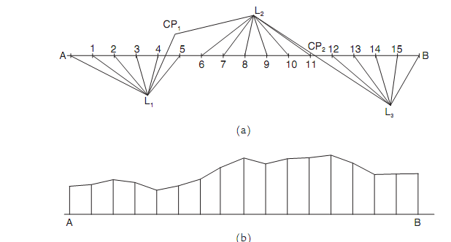

**Exercises 1**

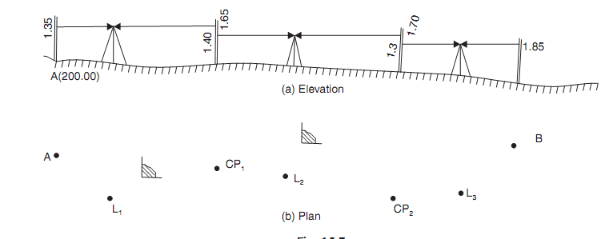

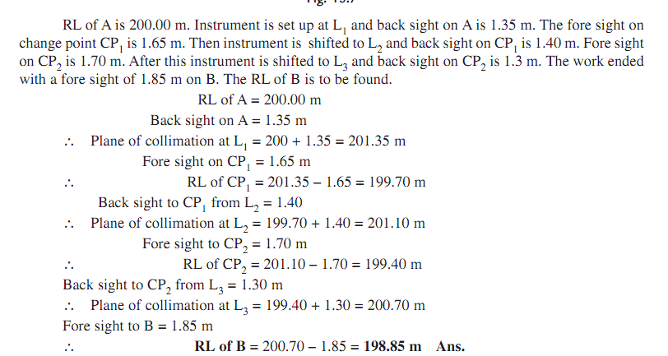

**Use line of collimation and rise methods**

To go the other direction, one can use the **same** right triangle. Since r is the distance from the origin to (x,y), it is the magnitude r=√x2+y2. Alternatively, from the equation (1), one can calculate directly that x2+y2=r2**cos**2**θ**+r2sin2**θ**=r2(**cos**2**θ**+sin2**θ**)=r2.

**To convert from Cartesian Coordinates (x,y) to Polar Coordinates (r,θ):**

1. r = √ ( x2 + y2 )
2. θ = tan-1 ( y / x )

**Q2**. Calculate the polar coordinates of the point”B” with respect to the point “A”.The rectangular coordinates of both points “B” and “A” are given below (in meters):XA=1248.25;XB=1872.43;YA=1864.38 and YB=1025.87/10 marks

**Q3**. Using the rise and fall method,calculate the elevations of the point B to D if the elevation of the point A(B.M) is 38.329.Also the arithmetic check has to be mentioned.

|  |  |  |  |  |  |  |  |
| --- | --- | --- | --- | --- | --- | --- | --- |
| Station | B.S | I.S | F.S | RISE | FALL | R.L | Remarks |
| A | 1.736 |  |  |  |  |  |  |
| B |  | 1.429 |  |  |  |  |  |
| C |  | 1.882 |  |  |  |  |  |
| D |  |  | 2.173 |  |  |  |  |

**Q4.** The following consecutive readings were taken with a level and a 4.0 m staff on continuously sloping ground at a common interval of 30m: 0.780, 1.535, 1.955, 2.430, 2.985, 3.480, 1.155, 1.960, 2.365, 3.640, 0.935, 1.045, 1.630 and 2.545

The reduced level of the first point A was 180.750m.Rule out a page of a level field book and enter the above readings. Calculate the reduced levels of the points by the collimation system **/10marks**

**Q5**

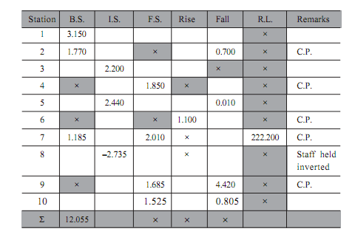

Q6. The figure below shows the leveling process. **(a)** Find out the difference in level

between **BM Rock** and **X**. **(b)** Determine the **RL** of **X** if readings are in feet.

**(c)** Convert the obtained results in (a) and (b) in metres. **(d)** Is there **fall** or **rise**

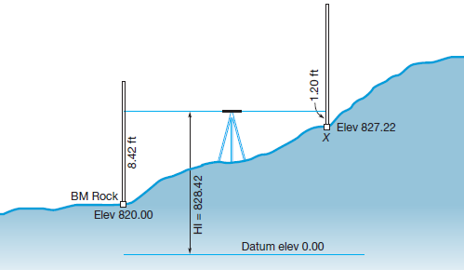 from **BM Rock** and **X**? **10 marks**

* **Aerial surveying (Photogrammetric)** :

Air surveys can be used to produce maps from primary sources, that is by taking measurements from aerial photographs. Points identified on overlapping aerial photographs may be transformed into positions on maps either by mechanical analogue means or through the use of mathematical techniques. The processes, known as photogrammetry, require some ground measurements to be taken in order to establish the precise scale and orientation of any map in relation to the ground data.

USES:

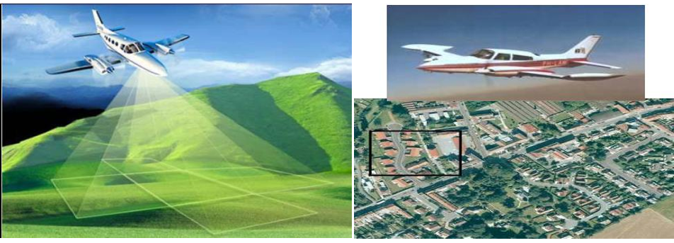

**TOPIC2: ESTABLISHING THE CONTROL POINTS**

**A benchmark** is a point of reference by which something can be measured. In

surveying, a "bench mark" (two words) is a post or other permanent mark

established at a known elevation that is used as the basis for measuring the

elevation of other topographical points.

**Different types of Bench marks are:**

1. **GTS Bench mark (Great Trigonometrically Survey):** are very accurate, and they are established by conducting high precise surveys.GTS benchmarks are decided by taking mean sea level as Datum. These are generally established by higher survey authorities of particular country in all points of the country.

**b) Permanent Bench mark:**  are established with reference

to GTS benchmarks. They are established by local state gorvnment agencies or railways at railways stations, public buildings, at bridges etc.

**c) Arbitrary Bench mark:** In most engineering projects, the difference in elevation is much more important compared to a reduced level when it

comes to mean sea level.

**d) Temporary Bench mark: (TBM)** is a fixed point with a known elevation used for

level control during construction works and surveys.

Topic 2: Purpose of establishing benchmark before setting out:

* To base other points off of.
* Assign it an elevation, and other points that are surveyed off
* Bench mark is established to ensure all existing and proposed construction works

**Factors considered while setting bench mark**

* Survey bench mark are selected and established on position on site according to site plan and specification
* Select a suitable site for a new bench mark

**TOPIC 3:RECORDING CIVIL STRUCTURES SURVEY DATA**

1. **ROAD**

**A road may have three location:**

**✓ Valley location**

**✓ Cross-country location**

**✓ Ridge line location**

**a) In the case of valley location, the route follows the valleys and so:**

It has few excessive grades (slopes).

There is often danger of washouts and floods.

A number of bridges may be required, to cross streams or rivers that found in this valley.

**b) In the case of cross-country location, the route is located in opposition to the drainage and so:**

➢ The route crosses the bridges very often.

➢ It will have steep grades.

➢ The construction costs along such a line may also be excessive.

**c) Locations along Ridge line are:**

➢ Relatively free from drainage problems and major drainage structures(bridges).

➢ Also, steep grades are encountered when the location drops into valleys or when the ridge is regained.

**1.2. General information:**

The relative elevations of points may be determined from the topographic map. The notes and records

may be marked directly on map or notes may be kept separately in a narrative form.

While all notes and records are marked on the map, this shows the several routes that are practicable,

the controlling points or obligatory points such as towns, markets and production centers.

There are also important topographic features, and all other details that may possibly be helpful in the

selection of route location.

**The map is supplemented by reconnaissance notes which may contain the following:**

**1.** The character of the terrain between termini or major controlling points. The terrain may be generally classified as level, rolling and mountainous.

**2.** Possible ruling gradients.

**3**. Stream crossings. This tends to a careful study of flow rate, high-water elevation, flood conditions, Character of banks, and the width of the stream. A suggested type of structure with most desirable

points of crossing should be noted on the map.

**4.** Information about other route crossings.

**5.** Obligatory points such as intermediate towns, markets or production centers. By pass locations

should be indicated in the notes for all small towns and cities for the more important routes.

Provisions should be considered for connections of the route of these centers of population.

**6.** Geological characteristics of area that affect foundation for bridges, etc… The presence of rock outcrop, swamps, varying soil types and dangerous possibility of landslides is very important.

**7.** Availability of building materials, labor and sites of quarries etc.… nearby the proposed route.

**8.** Value of the land to be acquired.

Note that, all these points contribute in choosing the best route location as they affect economy of the route before, during and after construction.

2.DAM RECORDING DATA

Dam data" typically refers to the information and metrics collected related to dam operations and management. This can include various types of data such as:

1. **Hydrological Data**: Information about water levels, flow rates, rainfall, and reservoir capacities.
2. **Structural Data**: Details on the dam's physical condition, materials, and any maintenance records.
3. **Environmental Data**: Impacts on local ecosystems, including fish populations and water quality.
4. **Operational Data**: Records of dam operations, including power generation (for hydroelectric dams), flood control measures, and water release schedules.

Site reconnaissance of a dam involves a thorough assessment of the dam site and its surroundings. typically included in a site reconnaissance:

**1. Visual Inspection**

* **Dam Structure**: Assessing the physical condition of the dam, including cracks, erosion, and overall integrity.
* **Spillway and Outlets**: Checking for blockages, structural issues, and proper functioning.
* **Reservoir Conditions**: Observing water levels, sediment accumulation, and vegetation growth.

**2. Topographical Assessment**

* Evaluating the terrain and surrounding land features, including slopes, drainage patterns, and potential erosion sites.

**3. Hydrological Evaluation**

* Reviewing water sources feeding the dam, drainage areas, and downstream impacts.
* Assessing flood risk and historical flood events in the area.

**4. Geotechnical Investigation**

* Examining soil and rock stability around the dam and its foundation.
* Collecting samples for laboratory analysis to evaluate soil properties.

**5. Environmental Considerations**

* Identifying local flora and fauna, as well as any ecological impacts related to the dam.
* Checking for compliance with environmental regulations and assessing potential mitigation measures.

**6. Safety Features**

* Inspecting safety measures, such as emergency spillways, monitoring equipment, and warning systems.

**7. Access and Logistics**

* Evaluating access routes for maintenance and emergency response.
* Assessing the availability of resources and services in the vicinity.

**8. Regulatory and Historical Context**

* Reviewing permits, historical records, and previous inspection reports to understand the dam's operational history.

**3.PIPELINE RECORDING TDATA**

Recording data for pipelines involves systematic approaches to monitor various parameters critical for safe and efficient operation. Here are the primary types of data recorded for pipeline management:

**1. Operational Data**

* **Flow Rates**: Measurements of fluid flow through the pipeline, often monitored continuously.
* **Pressure Levels**: Regular monitoring of pressure at various points to detect leaks or blockages.
* **Temperature**: Recording the temperature of the fluid being transported, which can affect pressure and flow characteristics.

**2. Maintenance Records**

* **Inspection Logs**: Documentation of regular inspections, including findings and any maintenance performed.
* **Repair History**: Records of repairs, replacements, or upgrades made to the pipeline.

**3. Hydraulic Data**

* **Head Loss**: Calculating pressure loss due to friction and elevation changes within the pipeline.
* **Hydraulic Models**: Data used in simulations to analyze flow characteristics under various conditions.

**4. Geospatial Data**

* **Pipeline Route Mapping**: Geographic coordinates and mapping of the pipeline's route using GIS.
* **Proximity to Infrastructure**: Information about nearby roads, buildings, and natural features that may impact the pipeline.

**5. Environmental Data**

* **Leak Detection**: Data from sensors designed to identify leaks or anomalies in the pipeline.
* **Impact Assessments**: Information on potential environmental impacts related to pipeline operations

**Example of data recording of road**

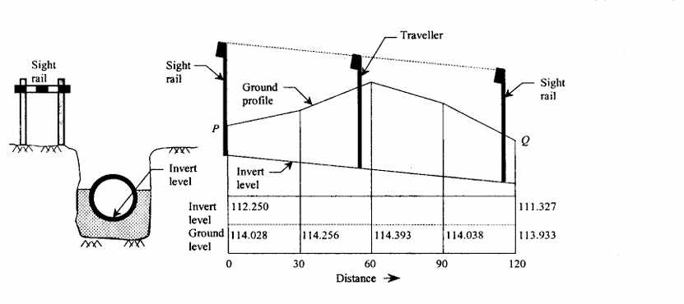

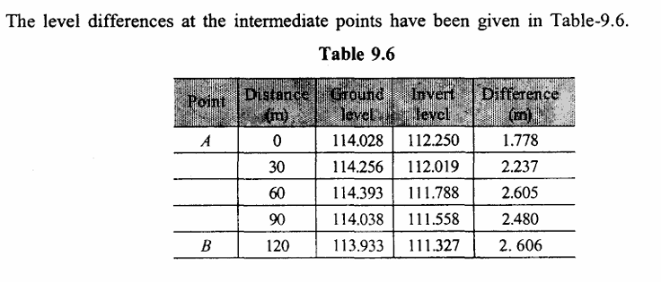

**I.C.2.2: PROCESSING DATA OF CIVIL STRUCTURES**

2.2.1: **DOWNLOADING DATA**

In modern civil engineering, the management and analysis of data are critical for the design, construction, and maintenance of structures such as bridges, buildings, dams, and roads.